Human Emotion Detection Using Open CV

Saji Krishna R S

*Computer science and engineering(Iot)*

*Shiv Nadar University* Chennai,India

sajikrishna22110163@snuchennai.edu.in

***Abstract -*** **Emotion Detection through Facial feature recognition is an active domain of research in the field of human-computer interaction (HCI). Humans are able to share multiple emotions and feelings through their facial gestures and body language.** **Humans are able to share multiple emotions and feelings through their facial gestures and body language. In this project, in order to detect the live emotions from the human facial gesture, we will be using an algorithm that allows the computer to automatically detect the facial recognition of human emotions. Main objective of this research is to sight object of interest in real time and to stay chase of constant object supported camera and picture set rule by means of Open CV (a python library) and Python language. The technique includes 3 parts: recognition module, coaching module, identification library.** **In this research paper, we will demonstrate an effective way to detect emotions like neutral, happy, sad, surprise, angry, fear, and disgust from the frontal facial expression of the human in front of the live webcam**

***Keywords: Human Emotion Recognition, Emotion detection, Open CV.***

1. INTRODUCTION

Human emotion detection is a technique which is used to distinguish the person’s emotion from the motion image or pictures source it without human assistance. In 1960s, face distinguishing was proposed by Woodrow Wilson Bledsoe. Bledsoe proposed a mechanism that could distinguish pictures of face by using what’s known as a RAND tablet, a device that people could use to emit electromagnetic rays. Since then, the PC is being continuously upgraded and enhanced, the technology is slowly evolving and are being used most in daily life routine object. It has been utilized largely for criminalist by laws judicial and military jobs [1]. As many of algorithm are brought for emotion detection and emotion recognition which assumed as a milestone. In this research paper, details will be discussed on face detection technique used to detect faces of individuals whose images are saved in the dataset and a model is developed for the evaluation of different dataset. The overview of this system is illustrated.

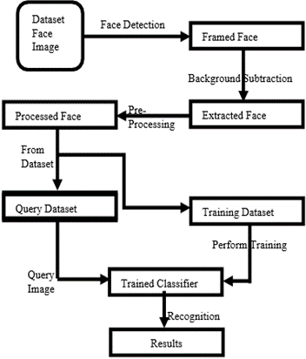

**Figure 1**. System Overview

1. LITERATURE SURVEY

Many researches had already been analyzed in emotion detection and feature extraction. Some of the important methods are as discussed below:

1. *Linear Discriminate Analysis*

LDA is a procedure of finding a linear mixture of elements that separate or divide more categories of things or occasion. Line layout can be achieved from the result. A higher number of pixels are used to represent the emotion on a computer screen. Pre-segmentation Analysis by line is used to minimize traits and make it manageable. The new dimension is a linear mixture of the pixel values that make up the template.

1. *Principal Component Analysis*

PCA involves an arithmetical process that converts a number of fickle that may be associated with a small number of unconnected variables. Data conflicts are calculated by the first major components and subsequent components cause

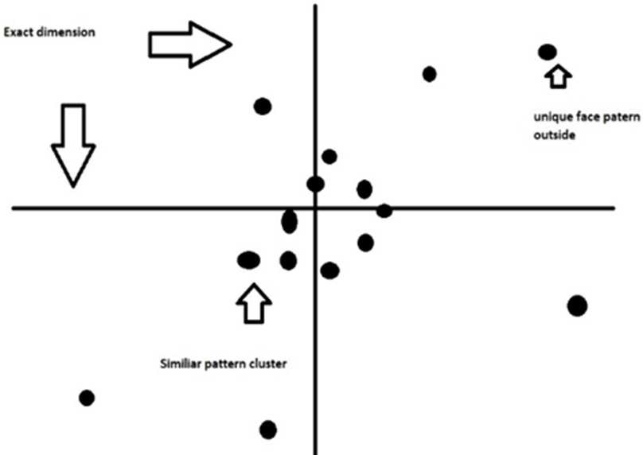further variability. Analyzing the data for testing and making models predicting PCA is a widely used tool. Eigen value calculation of the data matrix covariance or single value matrix data decomposition was performed with the help of PCA. Eigenvector based multi-variate analysis was facilitated with the use of PCA. Existing variations in data are best detailed by exposing the inside anatomy of the raw data which inspect one of the most vital functions.

Cov(𝑥, 𝑦) = 1/𝑛 ∑𝑛 (𝑥i − ̅𝑥̅̅) (𝑦i − 𝑦̅) (1)

i=1

Covariance Formula

1. *Hidden Markov Model*

The Markov Hidden Model (HMM) are mathematical model utilized to elaborate the emergence of tangible situation based on interiors, which are not straightly in view. The examine situation is known the `sign 'and is a sub-element of the` status' [2]. Markov’s hidden models are best known for their effectiveness in the care of temporary patterns such as long para, written article, touch examine, marking part of article, partial extraction and bioinformatics.

1. PROBLEM DEFINITION

Detecting human emotions is essential for creating intelligent human-computer interfaces, interactive conversations, animated videos, video conferences, and lifelike animated characters. To do this, various models have been developed to analyze facial images. One such model, called Eigen's facial expression, was introduced by Sirovich and Kirby. It's a method used to break down facial expressions into key components. What's unique about this method is that it uses statistical information from different facial images to identify important facial features. This makes it robust and able to work in various situations, even when there are changes in lighting, angles, hair, or when the images are not very clear.

Eigen's facial features are more reliable and biologically accurate compared to other methods that focus on specific local facial features like the eyes, nose, and mouth, and their distances from each other. This makes Eigen's method a valuable tool for recognizing and understanding human emotions in computer programs and animations.

Eigen's facial features offer a useful method for processing images in computer networks. However, there's a significant issue with the current Eigen face model. This model works well when dealing with one-dimensional images taken from a narrow front-facing angle. But it struggles when you have images of the same face taken from different angles. For instance, if you take three pictures of the same person from different angles, the Eigen face model may not correctly recognize them as the same person. This limitation reduces its accuracy and performance in situations with varying viewing angles.

**Figure 2**: The different face space and with different view angles.

1. PROPOSED TECHNIQUE

Object Detection using Har feature-among deluge segments is a better way to find an object suggested by Paul Viola and Michael Jones in their paper, "Rapid Object Detection uses the Boosted Cascade of Simple Features" in 2001. It is a system-based learning method where cascade activity is trained from many good and bad pictures. It was utilized to search objects in different pics. Here we will implement it on human emotion recognition. Startingly, the algo requires a lot of positive emotion specific images (face images) and negative emotion specific images (face images) to train the distinguisher.

Then it is required to remove the characteristics from it. In present case, the Har features displayed in picture below are used. They are like our convolutional kernel. Each element is the same number achieved by neglecting the total number of pixels under a cream rectangle from a pixel’s dot under a grey rectangle.

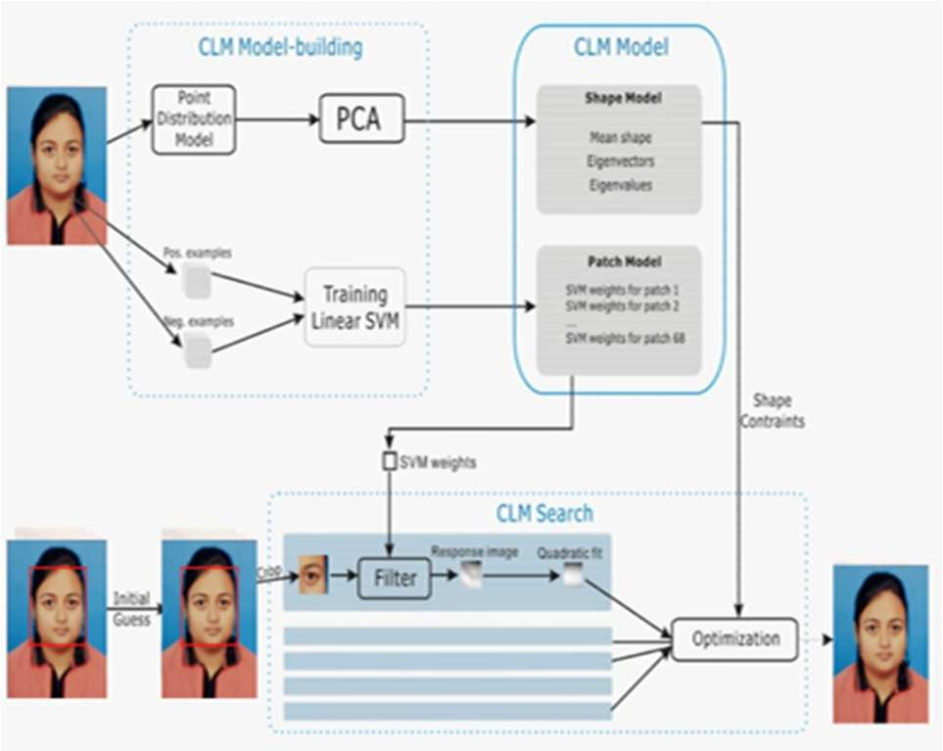

**Figure 3**. PCA Working

Now, every permutated shape and geographic of each kernel are utilized to compute many characteristics. To compute every characteristic, we need to search the addition of

the pixels under cream and grey rectangles. To compute it, they joined pics. However, enlarge your picture, it minimizes the computation of a pixel to a function including just 4 pixels. It reduces the time. But of all these characteristics we computed, most of them are unnecessary. For example, consider the picture downside. The above line display two nice characteristics. The firstly selected characteristics look too specified on an area where the eye region is generally darkest than the nose, cheek region.

𝐶o𝑚𝑏i𝑛i𝑛𝑔 e𝑞𝑢𝑎𝑡io𝑛 2 𝑎𝑛𝑑 3,we get ,

𝜎2 = 1 ‖𝐴 ‖2 (4)

𝑣

𝑛

𝑣 ⋅ w = 𝑣𝑇 ⋅ w ( 5)

𝐶o𝑚𝑏i𝑛i𝑛𝑔 e𝑞𝑢𝑎𝑡io𝑛 4 𝑎𝑛𝑑 5 , we 𝑔e𝑡 ,

1 ‖𝐴 ‖2 = 1 (𝐴𝑣)𝑇𝐴𝑣

The second option relies on the idea that the eyes are usually darker than the nose bridge, and we don't focus on the cheeks or other areas. We use AdaBoost to pick the best features from a pool of over 190,000 options. We test each feature with all the training images. In each case, the process encounters challenges and difficulties that are hard to imagine. Of course, there will be mistakes or incorrect classifications along the way. We choose the features with the fewest errors because they are the most reliable in distinguishing different facial expressions in the images. Initially, all pictures are given the same importance. However, with each round of analysis, the misclassified images gain more importance (weight). This process is repeated, and new error rates and weights are calculated. This continues until we achieve the desired level of accuracy or error, or until we've identified the necessary set of features.

In the final category, we considered the importance of less powerful characteristics. These traits, when used on their own, can't reliably identify faces. However, when combined with other features, they become an effective tool for face detection. The research found that even using just 300 features, we can achieve an 85% accuracy rate. The complete set comprises about 7000 characteristics. Now, when you take a picture, you break it down into small 24x24 windows and use 6000 features to check if each window contains a face. But most of the image isn't the face. To save time, it's a smart idea to quickly rule out areas that don’t have a face. If a window doesn't seem to contain a face, we discard it and don't reconsider it. Instead, we focus our efforts on areas where there might be a face. To make this process efficient, the concept of a "Cascade of Classifiers" was introduced. Instead of using all 7000 elements in a single window, we divide them into different groups and apply them one by one. If a window fails the first group of checks, we immediately reject it, and we don't bother with the rest. If it passes the first group, it moves on to the second group, and so on. Only the windows that successfully pass through all the groups are considered as containing a face.

Projected measurement vector

p =Av (2)

According to variance formula,

𝑛 𝑣 𝑛

= 1 (𝑣𝑇𝐴𝑇𝐴𝑣)

𝑛

(f𝑟o𝑚 𝑡𝑟𝑎𝑛𝑠𝑝o𝑠e 𝑝𝑟o𝑝e𝑟𝑡ie𝑠)

= 1 (𝑣𝑇𝐶𝑣)

𝛼𝑛

=𝑣𝑇𝐶𝑣

=𝑣𝑇𝜆𝑣 (f𝑟o𝑚 ei𝑔e𝑛𝑣e𝑐𝑡o𝑟 𝑑efi𝑛i𝑡io𝑛)

=(𝜆𝑣𝑇𝑣)

(from Associativity of scalar multiplication)

1 ‖𝐴 ‖2 =𝜆 (6)

𝑣

𝑛

Combining equation 4 and 6, we get,

𝜎2 = 𝜆

𝑝

Proving lemma 1, confirm that the removing of eigen vector with 0, eigen value would not be overripe.

1. RESULT DISCUSSION AND ANALYSIS

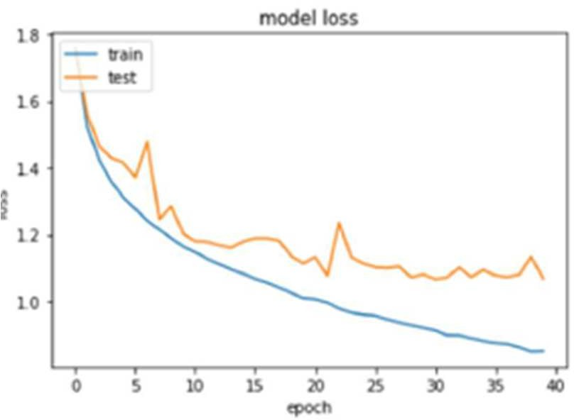

**Figure 4.** Mean Square Error or drop per epoch.

𝜎2 = 1 ∑𝑛 (𝑝 − 𝑝̅)2 = 1 ∑𝑛 𝑝2

𝑛 i=1 i 𝑛 i=1 i

(From (𝑝̅2) = 1 ∑𝑛 𝑝i) 𝜎2 = 1 ||𝑝||2 (3)

𝑛 i=1 𝑣 𝑛

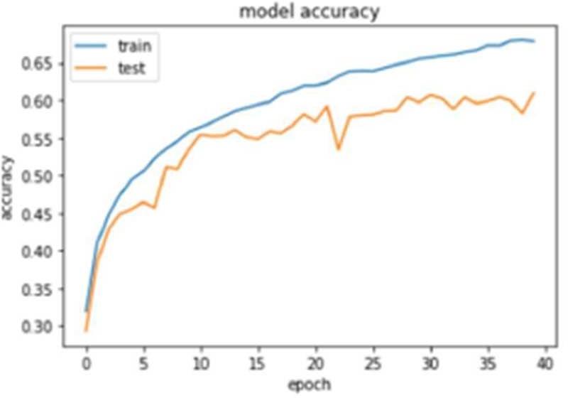

**Figure 5**. Model Accuracy per epoch.

Fig.4. detailed about training loss versus Validation Loss, greater the drop, mean square error gives the less pattern, therefore, the validation drop would be greater graph. The scene of experimental give us good outcome about model accomplishment of MSE data display declining as the epoch increases. Other graph in fig 5, accuracy of model was suggested growing value from the starting of the procedure, it means, little the mean square error, so we could get the higher accuracy value of the model.

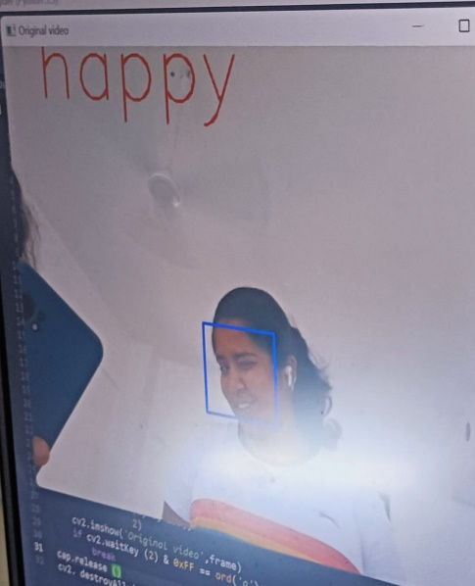

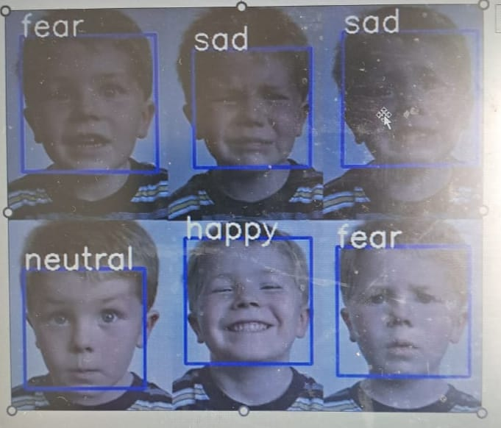

1. CONCLUSION

We have effectively implemented the previously discussed concept and now possess a functional Face Emotion Detection model capable of real-time person facial expression analysis. In this section, we present a comprehensive experiment comparing various algorithms for human emotion recognition. We will assess these different methods using metrics such as accuracy, precision, detection ratio, and wrong recognition rate. Accuracy, in particular, signifies the percentage of correct classifications, encompassing both true positives and true negatives.

In our research, we've used a simple method called Eigenfaces for detecting human emotions in grayscale images. We start by converting colorful pictures to black and white and then use Histogram Equalization to adjust brightness and contrast automatically.

For more advanced results, we can explore color-based emotion detection methods using color spaces like HSV instead of RGB. We could also consider using additional techniques like edge enhancement, contour recognition, or motion analysis.

To make sure images stay the same in appearance when we change their size, we need to understand image resizing. We use a tool in OpenCV called the Haar Cascade classifier for emotion detection. It scans photos, whether they're in a folder or video, and labels areas as "Happy" or "Sad." The classifier focuses on faces with a fixed size of around 50x50 pixels. Since faces can be different sizes in images, the algorithm checks multiple sections and scales. Even though this might sound complicated, optimizations in the algorithm make this process faster, even for various face sizes. The classifier uses an XML file to know where to find and identify faces in each image.

REFERENCES

1. Revathy, N., & Guhan, T. (2012). Face recognition system using back propagation artificial neural networks. *International Journal of Computer Science and Information Technology*, *11*, 68-77.
2. Turk, M. A., & Pentland, A. P. (1991, January). Face recognition using eigenfaces. In *Proceedings. 1991 IEEE computer society conference on computer vision and pattern recognition* (pp. 586-587). IEEE Computer Society.
3. Rady, H. (2011). Face Recognition using Principle Component Analysis with Different Distance Classifiers. *IJCSNS International Journal of Computer Science and Network Security*, *11*(10), 134-144.
4. Ahmad, F., Najam, A., & Ahmed, Z. (2013). Image-based face detection and recognition:" state of the art". *arXiv preprint arXiv:1302.6379*.
5. Khan, S., Akram, A., & Usman, N. (2020). Real Time Automatic Attendance System for Face Recognition Using Face API and OpenCV. *Wireless Personal Communications*, *113*(1), 469-480.
6. Goyal, K., Agarwal, K., & Kumar, R. (2017, April). Face detection and tracking: Using OpenCV. In *2017 International conference of Electronics, Communication and Aerospace Technology (ICECA)* (Vol. 1, pp. 474-478). IEEE.
7. De Silva, L. C., Miyasato, T., & Nakatsu, R. (1997, September). Facial emotion recognition using multi-modal information. In *Proceedings of ICICS, 1997 International Conference on Information, Communications and Signal Processing. Theme: Trends in Information Systems Engineering and Wireless Multimedia Communications (Cat.* (Vol. 1, pp. 397-401). IEEE.
8. Ninaus, M., Greipl, S., Kiili, K., Lindstedt, A., Huber, S., Klein, E., ... & Moeller, K. (2019). Increased emotional engagement in game-based learning–A machine learning approach on facial emotion detection data. *Computers & Education*, *142*, 103641.
9. Miyakoshi, Y., & Kato, S. (2011, March). Facial emotion detection considering partial occlusion of face using Bayesian network. In *2011 IEEE Symposium on Computers & Informatics* (pp. 96-101). IEEE.
10. Ahmad, F., Najam, A., & Ahmed, Z. (2013). Image- based face detection and recognition:" state of the art". *arXiv preprint arXiv:1302.6379*.

Facial emotion detection to assess Learner's State of mind in an online learning system. In *Proceedings of the 2020 5th International Conference on Intelligent Information Technology* (pp. 107-115).

1. Gupta A., Gupta M., Chaturvedi P. (2020) Investing Data with Machine Learning Using Python. In: Kapur P.K., Singh O., Khatri S.K., Verma A.K. (eds) Strategic System Assurance and Business Analytics. Asset Analytics (Performance and Safety Management). Springer, Singapore. https://doi.org/10.1007/978-981-15-3647- 2_1.
2. Sharma, S., Mishra, V.M. Development of Sleep Apnea Device by detection of blood pressure and heart rate measurement. *Int J Syst Assur Eng Manag* **12,** 145–153 (2021). https://doi.org/10.1007/s13198-020-

01041-3.